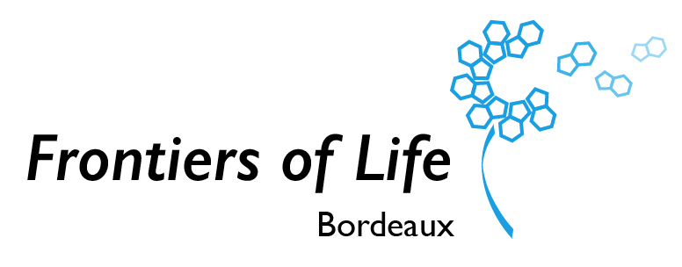

Frontiers of Life

Post Doc Call 2024

## Call for Post-doc positions in Frontiers of Life

Frontiers of life is a Univ. Bordeaux Research Network (RRI) focused on the re-engineering of living systems and artificial cells. It is an interdisciplinary network spanning physics, chemistry, life science and engineering and funded by the Univ. Bordeaux. The current call aims at supporting the activities of our research community and strengthening the international visibility of our research activities.

The present call aims at funding post-doc positions on new research projects aligned with the main objectives of Frontiers of Life.

* The call is open with a deadline on March 15 2024 for the submission of proposals. Applications should be sent to : rri.frontiersoflife.copil@diff.u-bordeaux.fr
* The call is open to the broad community of scientists on the campus of the University of Bordeaux having scientific activities of relevance to the research themes of Frontiers of Life.
* Joint supervision between PIs is preferred but not mandatory.
* Multidisciplinary projects are preferred but not mandatory.
* The duration of the post-doc position can be 12, 18 or 24 months.
* The funding will only cover personnel costs. Details must be given on the plan of the PIs to cover or experimental costs, to demonstrate feasibility.
* **/!\** For the accepted projects, the details of the hiring procedures will be explained to the laureates in the decision letter. The position will be centrally funded by the RRI.

All proposals will be evaluated within the steering committee and ranked according to the following criteria:

* Scientific quality of the proposal, its objectives and feasibility of the project: 50%
* Added value for Frontiers of Life and alignment with the objectives of Frontiers of Life, long term perspective of the project: 30%
* Quality of the researchers involved in the supervision and of the organization implemented, capacity to supervise: 20%

# 1. Overview

|  |  |
| --- | --- |
| **project title** |  |
| **project acronym** |  |
| **duration of the position** (in months) |  |
| **name of the principal investigators** |  |
| **laboratory (main host)** |  |
| **list of the partners**  **and lab of the partner** |  |

2. Description (2 pages max)

## *2.1 Context & state of the art*

## *2.2 Scientific Objectives*

## *2.3 Methodology & Expected Results*

# 3. Integration in frontiers of life (1 page max)

## *3.1 Alignment with the RRI objectives and integration in the network activities*

## *3.2 Plan to fund research expenses*

## *3.3 Request*

|  |  |  |
| --- | --- | --- |
| **Requested resources** | | |
| Staff | | |
| Duration (12 / 18 / 24 months) | *Supervisor* | *Hosting laboratory* |
|  |  |  |

## *3.4 Duration justification*

(Note: In case the position is intended to extend an on-going post-doc position, a short description of the project and funding must be provided.)

## *3.5 Long term perspective to continue the project*

# 3. Consortium

|  |  |
| --- | --- |
| **OVERVIEW OF THE PARTNERS**  **(add more partners if necessary)** | |
| **Partner 1** | |
| **Name of the PI** |  |
| **Key personnel involved in the project** |  |
| **Role in the project** |  |
| **Partner 2** | |
| **Name of the PI** |  |
| **Key personnel involved in the project** |  |
| **Role in the project** |  |
| **Organisation description**  **Facilities involved in the project** |  |
| **Team** | |
| **Five recent publications related to the project (published between 2020-2024) by the consortium members (not necessarily joint publications)** |  |
| **Recent projects related to the current projects funded (between 2020-2024) by the consortium members (not necessarily joint projects)** |  |
| **Pending joint proposal applications** |  |

## General Management of Frontiers of Life

|  |  |  |  |
| --- | --- | --- | --- |
|  | **Project title** | Frontiers of Life | |
|  | **Project coordinator** | Jean-Christophe Baret | |
|  | **Coordinator’s position** | Full Professor at Univ. Bordeaux | |
|  | **Coordinator email address** | Jean-christophe.baret@u-bordeaux.fr | |
|  | **Coordinator’s lab** | Univ. Bordeaux, CNRS, CRPP, UMR5031 | |
|  | **Mots clés/Keywords** | Structural Biology | Synthetic Biology | Regenerative Medicine | Molecular Machines | Supramolecular Chemistry | Soft matter | Biophysics | Organ-on-chips | Artificial cells | Minimal cells | |
|  | **Project team / Steering Committee** | | |
|  | **Contact: rri.frontiersoflife.copil@diff.u-bordeaux.fr** | | |
|  | Name (lab) | Core competences | Role in Project Team |
|  | Jean-Christophe Baret  (CRPP) | Microfluidics, Bottom-up Synthetic Biology, soft matter physics | Director. Representative of the project, in charge of project management |
|  | Hamid Kellay (LOMA) | Soft matter physics and biophysics | Physical aspects. In charge of training |
|  | Sébastien Lecommandoux (LCPO) | Soft matter chemistry, artificial cells and biomaterials | Bottom-up syn bio. In charge of innovation |
|  | Carole Lartigue  (BFP) | Minimal cells and genetic engineering, Top-down synthetic biology | Top down syn bio.  In charge of communication and outreach |
|  | Axel Innis  (ARNA) | Structural biology, biochemistry, microbiology | Microbiology & structural biology |
|  | Joelle Amédée  (BIOTIS) | Regenerative medicine, biomaterials | Biomaterials and medical applications.  In charge of international relations. |

|  |  |  |
| --- | --- | --- |
| **Project PI** | | |
| Name | Lab | email |
| Carole Lartigue | **BFP - UMR 1332** | carole.lartigue-prat@inrae.fr |
| Yaser Hashem | **ARNA - U1212-UMR 5320** | yaser.hashem@u-bordeaux.fr |
| Valérie Desvergnes | **ARNA - U1212-UMR 5320** | valerie.desvergnes@u-bordeaux.fr |
| Nicolas Martin | **CRPP - UMR 5031** | martin@crpp-bordeaux.cnrs.fr |
| Jeanne Leblond-Chain | **ARNA - U1212-UMR 5320** | jeanne.leblond-chain@u-bordeaux.fr |
| Colin Bonduelle | **LCPO - UMR5629** | colin.bonduelle@enscbp.fr |
| Stéphane Arbault | **CBMN - UMR 5248** | stephane.arbault@u-bordeaux.fr |
| Anne Devin | **IBGC - UMR 5095** | anne.devin@u-bordeaux.fr |

Réseau de Recherche Impulsion

Frontiers of Life Bordeaux

rri.frontiersoflife.copil@diff.u-bordeaux.fr

Service d’Appui à l’Animation Scientifique des Départements de recherche (SAASD)

**CONTACT**

