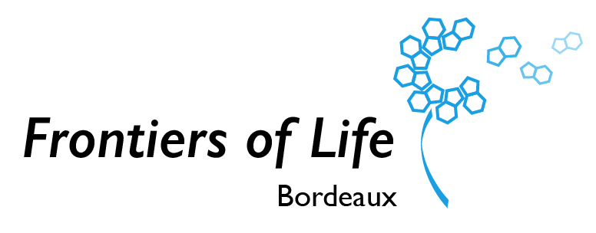

Frontiers of Life

Continuous Open Call 2024

## Continuous Open Call in Frontiers of Life

Frontiers of life is a Univ. Bordeaux Research Network focused on the re-engineering of living systems and artificial cells. It is an interdisciplinary network spanning physics, chemistry, life science and engineering and funded by the Univ. Bordeaux. The current call aims at supporting the activities of our research community and strengthening the international visibility of our research activities.

We will support:

|  |
| --- |
| A - Travel grants  Funding can be granted to travel to conferences on topics relevant to the program for participants presenting a talk or a poster at the conference. For students and post-docs, travel grants to international summer schools (eg Biomaterials summer schools, SynCellEU activities, GDR schools…) will be available. Priority will be given to PhD and Post-doc applicants but academic staff can also apply.  B - Setup of project proposals  Funding can be granted to support the setup of project proposals: organisation of meetings in Bordeaux, participation to networking events with colleagues from other networks. Priority will be given to academic staff but PhD and Post-doc applicants can also apply.  C - Support to international conferences  Frontiers of Life supports conferences organized or co-organized by members of our community. The application should include an overview of the total budget and the use of the Frontiers of Life funding must be explained as well as how the participation of Frontiers of Life will be acknowledged.  D - Invitation of international scientists  Travel costs for the invitation of international speakers can be granted. The seminar should be organised to be open to the broad community of Frontiers of Life. The support can be extended to the invitation of European scientists to participate to PhD defense jury.  E - Outreach activities  Funding can be granted to support the setup of experimental demonstrators / stands related to outreach events towards a lay audience (e.g. ‘Fête de la Science’, ‘Nuit des chercheurs’, …).  F – Other actions  We are open to any initiative and/or proposals that can enhance our visibility and increase our impact in the community. |

Our aim is to provide a reactive mechanism to fund initiatives from the community in a light format and as a continuous process without deadlines:

* The call is continuously open for a year until Dec. 31st 2024.
* The call is open to the broad community of scientists on Campus having scientific activities of relevance to the research themes of Frontiers of Life.
* All requests will be evaluated within the steering committee without specific deadlines.
* The typical budget per request is in the range 500 – 2 500 € depending on the activity but requests outside of this range can also be discussed with the steering committee.
* For applications dealing with travel expenses, train must be the preferred means of transportation. Plane option is possible when unavoidable.
* **/!\** For the accepted projects, the expenses will be centralized by Frontiers of Life financial manager Clara Merlet. The procedures will be explained to the laureates in the decision letter.
* The efficiency of this call to address its objectives will be evaluated by the steering committee at the end of 2024 to decide if it should be renewed for 2025.

## Application Form – 1 Page max

Applications should be sent by email to : [*rri.frontiersoflife.copil@diff.u-bordeaux.fr*](mailto:rri.frontiersoflife.copil@diff.u-bordeaux.fr)

|  |  |  |  |
| --- | --- | --- | --- |
| Name of the applicant |  | | |
| email address |  | | |
| Laboratory |  | | |
|  | | Yes | No |
| Request for funding for: | A – Travel Grant |  |  |
| B – Project Proposal Support |  |  |
| C – Support of International Conference |  |  |
| D – Invitation of international scientists |  |  |
| E – Support for outreach activities |  |  |
| F – Other actions |  |  |
| 1 – Details of the scientific activity and interest for the applicant (10-15 lines) | | | |
|  | | | |
| 2 – Potential Impact for Frontiers of Life and measures to enhance the visibility of the Frontiers of Life community (10-15 lines) | | | |
|  | | | |
| 3 – Requested amount (and budget allocation if relevant) | | | |
|  | | | |

## General Management of Frontiers of Life

|  |  |  |  |
| --- | --- | --- | --- |
|  | **Project title** | Frontiers of Life | |
|  | **Project coordinator** | Jean-Christophe Baret | |
|  | **Coordinator’s position** | Full Professor at Univ. Bordeaux | |
|  | **Coordinator email address** | Jean-christophe.baret@u-bordeaux.fr | |
|  | **Coordinator’s lab** | Univ. Bordeaux, CNRS, CRPP, UMR5031 | |
|  | **Mots clés/Keywords** | Structural Biology | Synthetic Biology | Regenerative Medicine | Molecular Machines | Supramolecular Chemistry | Soft matter | Biophysics | Organ-on-chips | Artificial cells | Minimal cells | |
|  | **Project team / Steering Committee** | | |
|  | **Contact: rri.frontiersoflife.copil@diff.u-bordeaux.fr** | | |
|  | Name (lab) | Core competences | Role in Project Team |
|  | Jean-Christophe Baret  (CRPP) | Microfluidics, Bottom-up Synthetic Biology, soft matter physics | Director. Representative of the project, in charge of project management |
|  | Hamid Kellay (LOMA) | Soft matter physics and biophysics | Physical aspects. In charge of training |
|  | Sébastien Lecommandoux (LCPO) | Soft matter chemistry, artificial cells and biomaterials | Bottom-up syn bio. In charge of innovation |
|  | Carole Lartigue  (BFP) | Minimal cells and genetic engineering, Top-down synthetic biology | Top down syn bio.  In charge of communication and outreach |
|  | Axel Innis  (ARNA) | Structural biology, biochemistry, microbiology | Microbiology & structural biology |
|  | Joelle Amédée  (BIOTIS) | Regenerative medicine, biomaterials | Biomaterials and medical applications.  In charge of international relations. |

|  |  |  |
| --- | --- | --- |
| **Project PI** | | |
| Name | Lab | email |
| Carole Lartigue | **BFP - UMR 1332** | carole.lartigue-prat@inrae.fr |
| Yaser Hashem | **ARNA - U1212-UMR 5320** | yaser.hashem@u-bordeaux.fr |
| Valérie Desvergnes | **ARNA - U1212-UMR 5320** | valerie.desvergnes@u-bordeaux.fr |
| Nicolas Martin | **CRPP - UMR 5031** | martin@crpp-bordeaux.cnrs.fr |
| Jeanne Leblond-Chain | **ARNA - U1212-UMR 5320** | jeanne.leblond-chain@u-bordeaux.fr |
| Colin Bonduelle | **LCPO - UMR5629** | colin.bonduelle@enscbp.fr |
| Stéphane Arbault | **CBMN - UMR 5248** | stephane.arbault@u-bordeaux.fr |
| Anne Devin | **IBGC - UMR 5095** | anne.devin@u-bordeaux.fr |

Réseau de Recherche Impulsion

Frontiers of Life Bordeaux

rri.frontiersoflife.copil@diff.u-bordeaux.fr

Service d’Appui à l’Animation Scientifique des Départements de recherche (SAASD)

**CONTACT**

